SEO Performance Report Template

## **1. Overview**

**Website Analyzed:** learnhowtobecome.org/

**Date Range:** 1st May 2024] to [1st July 2024

**Objective:** According to Semrush, the website has **29.9k**  per month of Organic traffic worldwide and **16.2K** per month of US traffic. The authority score of the site is **42**

## **2. Key Metrics Summary**

**Organic Traffic:** 29.9k per month

**Keyword Rankings:**

1. L[earn to truck drive](https://semrush.groupbuyseotools.store/analytics/keywordoverview/?db=us&q=learn%20to%20truck%20drive&currency=usd)
2. How to get a law degree
3. How to become a mechanical engineer
4. How to become a trucker

### H[ow to get a law degree](https://semrush.groupbuyseotools.store/analytics/keywordoverview/?db=us&q=how%20to%20get%20a%20law%20degree&currency=usd)

**Backlinks:** 53.9k

**Page Load Speed:**

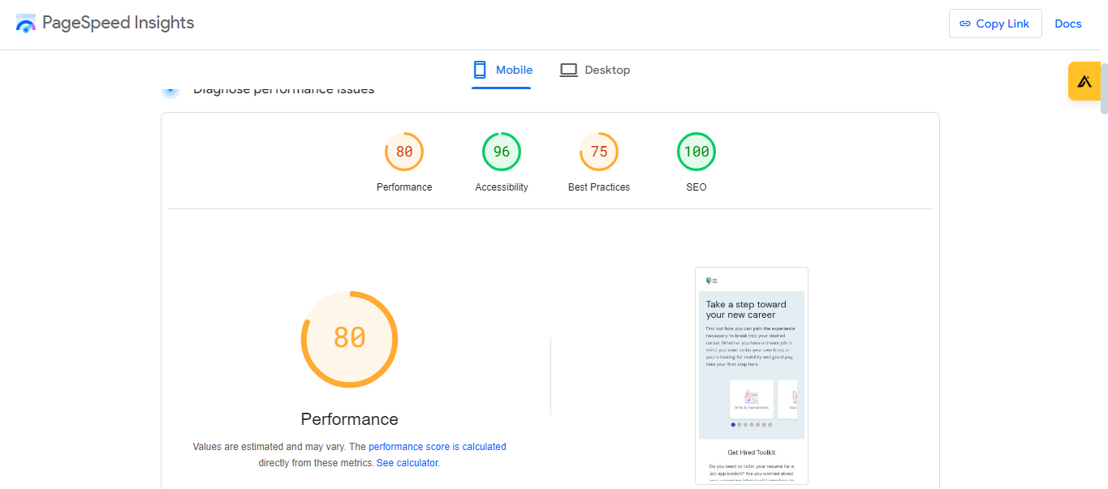

## **3. Analysis and Insights**

**Trends Observed:**

Increase/Decrease in organic traffic:- 4.9% decrease

Drop in keyword rankings:- 6.06% decrease

**Top-Performing Pages:**

**Urls Traffic Traffic Diff**

1. [www.learnhowtobecome.org/](https://semrush.groupbuyseotools.store/analytics/organic/overview/?db=us&q=https%3A%2F%2Fwww.learnhowtobecome.org%2F&searchType=url&currency=usd) 2.6k -188
2. [www.learnhowtobecome.org/electrician/ 1.4k +1.3k](https://semrush.groupbuyseotools.store/analytics/organic/overview/?db=us&q=https%3A%2F%2Fwww.learnhowtobecome.org%2Felectrician%2F&searchType=url&currency=usd)
3. [www.learnhowtobecome.org/mechanic/ 1.4k + 265](https://semrush.groupbuyseotools.store/analytics/organic/overview/?db=us&q=https%3A%2F%2Fwww.learnhowtobecome.org%2Fmechanic%2F&searchType=url&currency=usd)

**Areas for Improvement:**

The site home page ( <https://www.learnhowtobecome.org/> ) has a high FCP of 2.8s. It should be less than 1

**4. Recommendations**

**Content Optimization:**

**"Keyword"**

1. how to Become a doctor after 12th
2. how to become a doctor after high school
3. how to become a doctor in the United States?
4. How do I become a doctor in Canada?
5. how to become a doctor in Australia?
6. how to become a pediatric doctor?
7. how to Become a doctor in 5 minutes

**Technical SEO:**

The site's overall mobile speed is 80 and that should be above 90

**Link Building:**

Create relevant backlinks including ( Guest posts, forums, profiles, and article submissions). In today's SEO comment backlinks not work so I will not suggest that.

## **5. Next Steps**

There is no such a big drop in traffic. From the top 3 pages, only 1 loses traffic about -188 and others grow more than +1k. By focusing on untapped keywords and updating the other articles that are in between position top 5 to 15. The site easily ranks on those keywords within 2 to 3 months

## **6. Conclusion**

The website, learnhowtobecome.org, experienced a slight decrease in organic traffic (-4.9%) and a minor drop in keyword rankings (-6.06%) during the analyzed period. Despite this, the site has strong potential for recovery. The top-performing pages continue to attract significant traffic, with some seeing substantial growth. The key areas for improvement include reducing the homepage's First Contentful Paint (FCP) and optimizing for mobile speed. By targeting untapped keywords and refining content for those ranking between positions 5 to 15, the website is well-positioned to improve rankings and regain lost traffic within 2-3 months.